<LIMS/ N.S.Trading CO.>

Unite Soft Proposal

Version : 1.0

Effective Date : 07-Dec-2019

No. Of Pages : 9

DOC ID : 245

**SAC Code : 998314**

SAC Name : Information technology (IT) design and development services

GSTIN : 27ACYPH3960J1ZY

Client Information

|  |  |
| --- | --- |
| **Title** | **Details** |
| Name(point of contact) | Mr. RAHUL KUMAR |
| Contact | Contact:+91 07088010082  email: nstradingcompany2013@gmail.com, nstradingho2013@gmail.com  N.S.Trading CO.  (An ISO 9001:2015 Certified)  Shop No. 3, Sitaram Balaji Market, Dubey Ka Parao,  Aligarh. (Uttar Pradesh-202001)  Ph. No. 0571-2400288. |

Prepared By

|  |  |  |
| --- | --- | --- |
| **Title** | **Details** | **Signature and date** |
| Author | Zeyaul Haque |  |
| Contact | Mobile: +919892842076, Email:zeyaul@unitesoft.com |

Revision History

| **Version** | **Created / Modified On** | **Created / Modified By** | Sections Changed | **Reasons** |
| --- | --- | --- | --- | --- |
| 1.0 | 07-Dec-2019 | M. Z. Haque | - | Created |

Accepted By

| **Accepted By** | **Signature** | **Date** |
| --- | --- | --- |
|  |  |  |

# LIMS

## Introduction

LIMS is a web based solution for Material testing laboratory automation. A short introduction of software is attached below.

**Double click below icon to open a short presentation of LIMS.**



## Major Highlights

Below are the major module covered in the software

1. **Quotation module**
2. **Job Order module**
3. **Customer Database**
4. **Sample Inward**
5. **Test Plan**
6. **Sample Preparation Plan**
7. **Result Entry**
8. **Approve of test by head of department or approver**
9. **Print of Certificate**
10. **Dispatch of Certificate**
11. **Dispatch of returnable sample**
12. **Invoice Generation**
13. **Rate Master standard and customer wise**
14. **Discount management**
15. **Invoice export to Tally**
16. **Sample Re Test**
17. **Test Cancellation**
18. **SMS notification to customer**
19. **Email notification to customer**
20. **Pending sample report**
21. **Pending Sample Report**
22. **Performance Analysis report machine wise**
23. **Performance Analysis report technician wise**
24. **Other Report**
    1. Daily Sample Collection Summary
    2. Daily Sample Collection Full
    3. Daily Sample Detail
    4. Daily Sample Collection Full Report
    5. Daily Draft Summary(User wise)
    6. Daily Draft Detail
    7. Draft Pending Detail
    8. Daily Test Result Detail
    9. Test Result Pending Detail
    10. Pending Tests Summary
    11. Sample Status Detail
    12. Sample Not Given
    13. Customer Data
    14. Daily Sample Collector - Detail
    15. Daily Sample Collector - Summary
    16. Monthly Sample Collector - Summary
    17. Machine Analysis - Summary
    18. Technician Analysis
    19. Pending Test Detail By Test
    20. Complete Test Detail
    21. Service Tax
    22. Invoice Detail
    23. Test Detail By Test
    24. Pending Test
    25. Sample Returnable Status

## Some UI

1. Admin Dash board

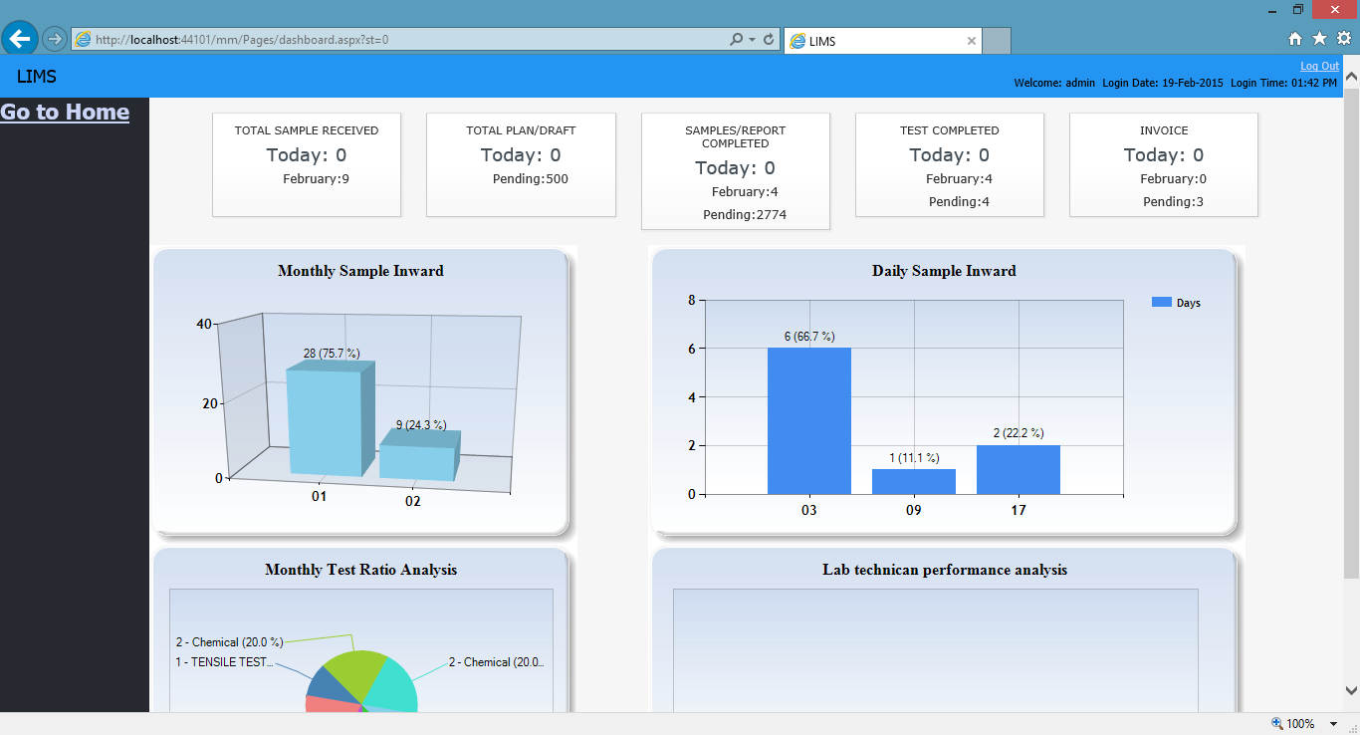

1. Samples Inward

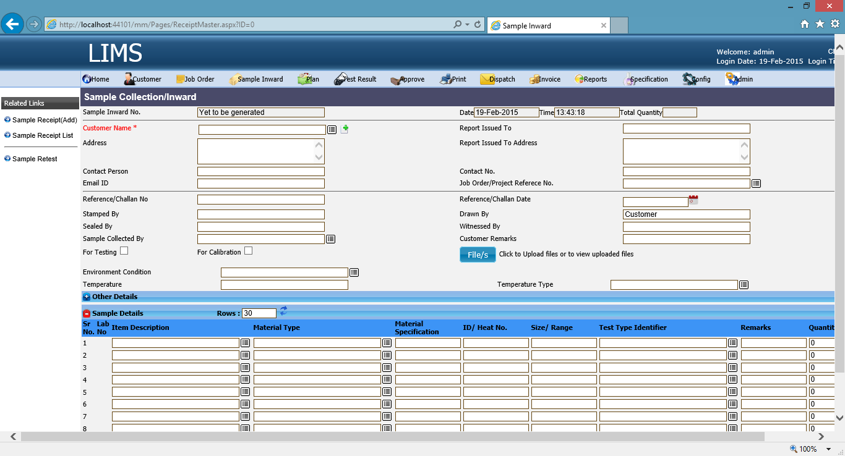

1. Certificate Administration

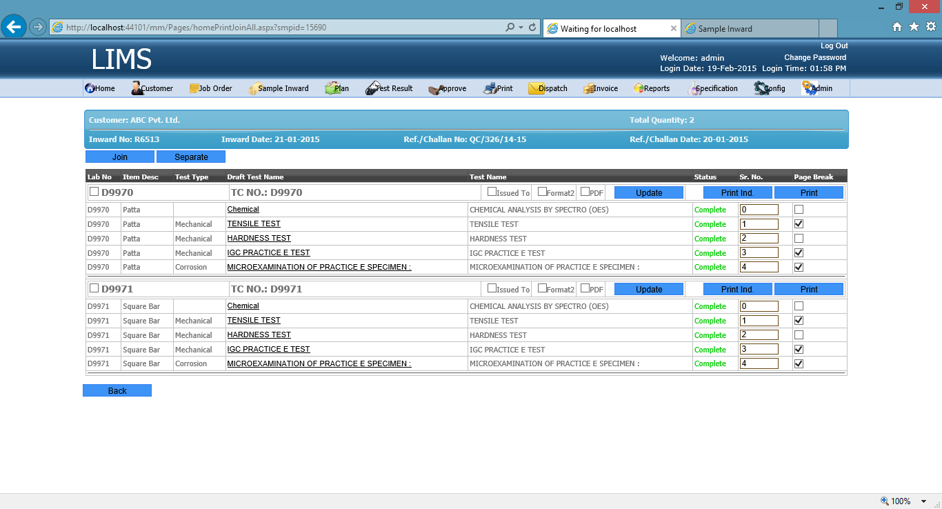

## Architecture

LIMS application and database server can be same, it is up to the requirement and infrastructure to change both server and mount on separate servers.



# Required Hardware and Other software

Server configuration

|  |  |  |
| --- | --- | --- |
| Server Configuration | Processor type | Intel Xeon Silver 4208 or above |
| RAM | Minimum 8GB |
| Hard Disk | 1 TB |
| Backup Drive | 2 TB |
| OS | Windows 2012 or above |
| Internet Connectivity | Dedicated |
| Database | Oracle 12c, or Oracle 11g Express or above |
| Office | Microsoft Word 2007 or above |
|  | | |
| Client Configuration |  | HTML 5 compatible browser, such as Chrome, Firefox, Edge, Opera, Safari |
| Branch Requirement | Internet | Static IP for security verification. |

# Commercial Terms and condition

As Per annexure I

# Annexure I

## Cost Estimate

|  |  |  |  |
| --- | --- | --- | --- |
| **Description** | **Rate (INR)** | **No of Concurrent User** | **Total (INR)** |
| Basic Software Setup Cost | 50,000/- |  | 50,000/- |
| Basic Software with three concurrent user at @ 20,000/- per user | 20,000/- | 3 | 60,000/- |
| Machine Integration  (Machine integration is only possible if vendor of machine allow to get data from their system) | 30,000/- | 5 | 1,50,000/- |
| **Total** | | | **2,60,000/-** |
| **Taxes of all nature are extra** | | | **GST 18%** |

Cost Structure, and payment Terms

1. Payment term will be 50% advance along with purchase order
2. Rest 50% after software installation and implementation
3. Delivery period and warranty conditions are subject to Force Majeure clauses

1. AMC cost will 15,000/- to be paid after completion of the first year
2. AMC support will be provided online and via telephonic. If required personal visit will be provided on extra cost.
3. Site visit expense has to bear by customer
4. Travelling/Food/Lodging/accommodation will be as per actual and payable by customer
5. Along with above site visit expenses a sum of 2,000/- (Two thousand) will be charged per day wise
6. Delivery period and warranty conditions are subject to Force Majeure clauses
7. Taxes of all nature are extra

# Terms and Condition

1. Hardware and required software will be provided by You
2. Unite Soft do not guarantee of compatibility of developed program, if client changes hardware or its operating system/environment.
3. You will have to give proper time in making us understand, requirement as well as process time to time when we require.
4. Unite Soft LIMS Software is the proprietary of Unite Soft.
5. You does not have rights to redistribute this software.
6. DISCLAIMER OF WARRANTY. The software is licensed “as-is”. You bear the risk of using it. UNITESOFT gives no express warranties, guarantees or conditions. You may have additional consumer rights under your local laws which this agreement cannot change. To the extent permitted under your local laws, UNITESOFT excludes the implied warranties of merchantability, fitness for a particular purpose and non-infringement.
7. LIMITATION ON AND EXCLUSION OF REMEDIES AND DAMAGES. Except for any refund Unite Soft may provide, you cannot recover any other damages, including consequential, lost profits, special, indirect or incidental damages. This limitation applies to:

• anything related to the software, services, content (including code) on third party Internet sites, or third party programs, and

• claims for breach of contract, breach of warranty, guarantee or condition, strict liability, negligence, or other tort to the extent permitted by applicable law.

It also applies even if UNITESOFT knew or should have known about the possibility of the damages. The above limitation or exclusion may not apply to you because your country may not allow the exclusion or limitation of incidental, consequential or other damages.

1. Refund: In case of refund of the payment, Unite Soft only refund the last given installment. Advance Payment is not refundable after one month of advance payment issued date.